Java Object-Oriented Programming Experimental Report
NO:1 Experiment name：Introduction
Student ID | 1607052230 | Name | 邱冠霖 | Class |  | 16软工1班
Location | 实1-218 | Teacher | 唐朝辉 | Time |  | 2018-03-23
1.Experimental purposes and requirements
1.1 Printing strings
1.2 Documentation
1.3 Identifiers
1.4 Syntax errors
2.Experimental equipment (environment) and requirements
2.1 Eclipse
2.2 Window XP
3.Lab Exercises
3.1 Pre-lab Exercises
3.2 Comments
3.3 Program Names
3.4 Recognizing Syntax Errors and Correcting Syntax Errors
4.Experimental results and data processing
5.Analysis and discussion
没有遇到什么问题，源代码都放在github上，欢迎讨论
https://github.com/kong1414/JavaLesson.git
6.Teacher Reviews  Signature：  Date： |  |  |  |  | Score
Experimental Report List
1 Pre-lab Exercises
1) Source code list
package Chapter01;
/**
* @Description:
* @Author: QiuGuanLin
* @Date: 2018/3/10 14:46
*/
public class CSYes {
//******************************************************
// File Name:Prelab Exercises
//
// Purpose:print out the following message
//**************************************************
public static void main(String[] args) {
System.out.println("Computer Science, Yes!!!!");
System.out.println("=========================");
}
}
2) Results data processing
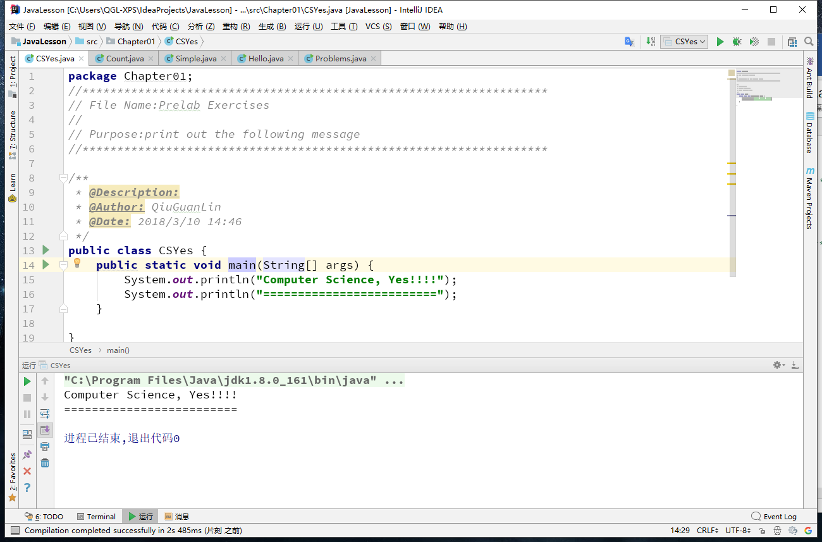

2 Poem
- Source code list
package Chapter01;
/**
* @Description:
* @Author: QiuGuanLin
* @Date: 2018/3/23 10:19
*/
public class Pome {
public static void main(String arg[]) {
System.out.println("Roses are red");
}
}

- Results data processing

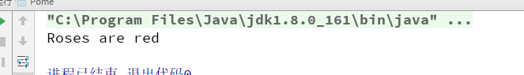

3) Answer questions
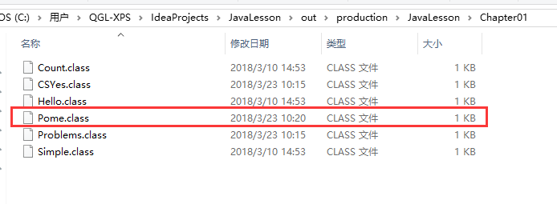

3 Comments
1) Source code list

package Chapter01;
/**
* @Description:
* @Author: QiuGuanLin
* @Date: 2018/3/10 14:46
*/
public class Count {
public static void main(String[] args) {
System.out.println("one two three four five");
System.out.println("un deux trois quatre cinq");
System.out.println("uno dos tres cuatro cinco");
}
}

2) Results data processing
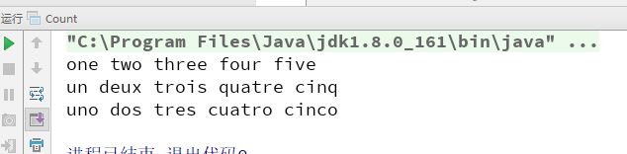

3) Answer questions
每个println语句前加个换行，每个注释之间加空行，是否更加可读？
答：否，并不是所有的换行和空行都会增加程序的可读性

去掉一个/看会发生什么错误。
答：语法错误，不能编译。

注释上再加注释会不会发生问题，如////。
答：没有影响。

4 Program Names
1) Source code list
package Chapter01;
// **************************
// Simple.java
//
// Print a simple message about Java. //
// ********************
/**
* @Description:
* @Author: QiuGuanLin
* @Date: 2018/3/10 14:48
*/
public class Simple {
public static void main(String[] args) {
System.out.println("Java rocks!!");
}
}

2) Results data processing

3) Answer questions
1. simple 不可以，已定义为类名
2. SimpleProgram 可以
3. 1Simple 不可以，不能以数字打头
4. _Simple_ 可以
5. *Simple* 不可以，不能除下划线、数字、字母，及$以外的字符
6. $123_45 可以
7. Simple! 不可以，不能除下划线、数字、字母，及$以外的字符

4)Error Analysis and Discussion

5 Recognizing Syntax Errors
1) Source code list
package Chapter01;
// **************************
// Hello.java
//
// Print a Hello, World message.
// ********************
/**
* @Description:
* @Author: QiuGuanLin
* @Date: 2018/3/10 14:49
*/
public class Hello {
// ----------------------------------
// main method -- prints the greeting
// ----------------------------------
public static void main(String[] args) {
System.out.println("Hello, World!");
}
}

2) Results data processing
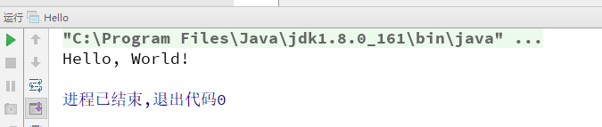

3) Answer questions

4)Error Analysis and Discussion

6 Correcting Syntax Error s
1) Source code list
package Chapter01;
// *************************
// Problems.java
//
// Provide lots of syntax errors for the user to correct.
// *************************
/**
* @Description:
* @Author: QiuGuanLin
* @Date: 2018/3/10 14:51
*/
public class Problems {
public static void main(String[] args) {
System.out.println ("!!!!!!!!!!!!!!!!!!!!!!!!!!!!!!!!!!!!!!!!!!!");
System.out.println ("This program used to have lots of problems,");
System.out.println ("but if it prints this, you fixed them all.");
System.out.println (" *** Hurray! ***");
System.out.println ("!!!!!!!!!!!!!!!!!!!!!!!!!!!!!!!!!!!!!!!!!!!");
}
}

2) Results data processing
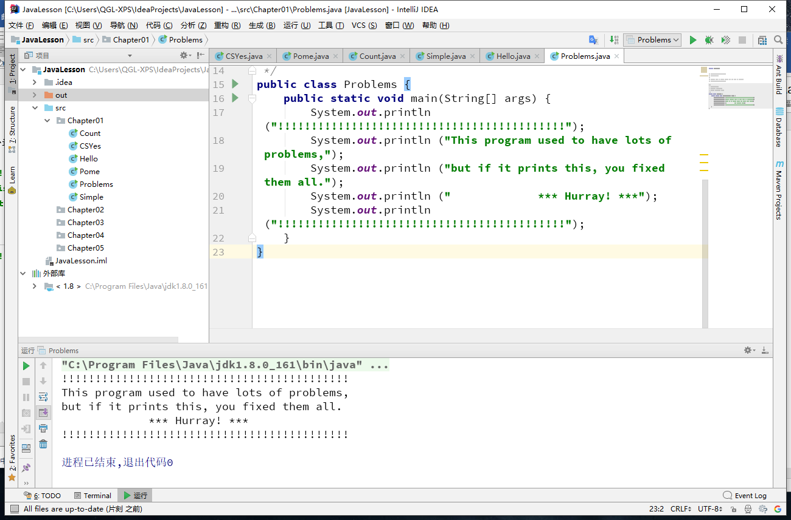

3) Answer questions
1、注释错误，//后面接换行后就没有注释效果
2、类名错误，修改为 Problem
3、Static开头s为小写
4、主方法前缺少返回值 void
5、string前S 为大写
6、第二个println （）里缺少前置 ”
7、第三条语句0ut应为out ，末尾缺少分号
8、第四条语句（）内缺少后置 “

4)Error Analysis and Discussion

